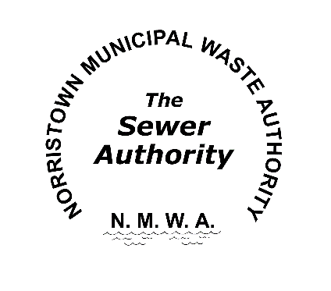**Norristown Municipal Waste Authority**

**25 E. Marshall St.**

**Norristown, PA 19401**

**P: (610) 270-3190**

**Position Title: Maintenance Mechanic**

**Summary of Responsibilities:**

The maintenance mechanic position is responsible for performing a highly diversified range of work to maintain, repair, and improve or replace facility equipment according to safety constraints, predictive maintenance schedules and operational standards to insure that the facility operates to the highest standards possible. This position is a first shift union position that requires weekend, holiday, and on-call work on a rotational basis.

**Essential Functions:**

* Perform preventative maintenance tasks on plant equipment and vehicles
* Troubleshoot and repair plant equipment and vehicles
* Maintain parts, supplies, and tool inventories
* Perform operations duties on an as needed basis
* Communicate and interact with all plant personnel including but not limited to: Management, Supervisors, Engineers, Vendors, Contractors, and Service Technicians
* Perform all other duties as requested by the Plant Manager and Supervisor

**Physical Demands**

* Be able to lift and carry 50 LB
* Be able to work on your feet for the duration of your shift
* Be able to work on ladders and in small spaces
* Considerable outside work, sometimes under adverse conditions

**Proficiencies**

* Mechanical and electrical aptitude (3 phase electrical & repair)
* Technical capacity (hydraulic systems, pumps, and motors)
* Self-driven and independent
* Communication (written/oral) and computer proficiency required
* Ability to interpret various types of blueprints and drawings

**Required Education and Experience**

* High school diploma or G.E.D.
* Technical training and/or apprenticeship, or equivalent years’ experience in related trade or field
* Hold a valid PA driver’s license
* PA DEP wastewater operator’s license

**Preferred Qualifications**

* Technical trade license (electrician, plumber, etc.)
* CDL driver’s license

The Norristown Municipal Waste Authority offers a competitive wage and benefits package. A pre-employment drug screening and physical examination are required.

Please send resume to: The Norristown Municipal Waste Authority, 25 E. Marshall St., Norristown PA 19401. Or email to shane@norristownsewer.org